PaleoRigor: a bounded research agent with a reproducible evidence trail for paleomicrobiome data processing
Author names to be completed
Affiliations to be completed
# These authors contributed equally, if applicable.
*Correspondence should be addressed to: [corresponding author email]
Keywords: paleomicrobiome; ancient DNA; PaleoRigor; research agent; large-language-model planning; bounded execution; human-in-the-loop analysis; preregistered evaluation; source-data verification; reproducible bioinformatics

Abstract
Background: Ancient microbial evidence informs research on past health, diet, and environments, but its scarcity and susceptibility to contamination demand careful analysis. Language models can now turn a research request into an analysis plan, but an unconstrained planner may reference files that do not exist, apply operations a format does not support, or answer a question the data cannot settle. Paleobiologists need such a planner to be bounded and its decisions to be recoverable afterwards.
Results: We developed PaleoRigor, a bounded research agent. A language model plans; a validator checks every file reference, format and step dependency before anything runs; execution is restricted to predefined local modules; and each run is exported with its plan, intermediate files, checksums and decision record. The agent refuses out-of-scope requests with a named reason code rather than substituting an alternative analysis. In a preregistered, frozen held-out evaluation, PaleoRigor passed 23 of 24 runs (95.8%; Wilson 95% confidence interval, 79.8–99.3%): 11 of 12 supported workflows and all 12 prespecified boundary decisions. An ablation that removed the PaleoRigor planning contract from the same model passed 19 of 24 (79.2%). Repeating the frozen design with a second model configuration yielded 24 of 24 successes for PaleoRigor and 19 of 24 for the ablated arm. Across both configurations, PaleoRigor passed 47 of 48 runs (97.9%), compared with 38 of 48 (79.2%) for the ablated arms. Every one of the 96 run labels was recomputed from retained records and matched. Dataset-level tests matched read counts and compressed-file sizes for six public sequencing records and documented the removal of 114 duplicate table rows. An audit of a retraction-associated record also illustrated how expert review limited conclusions to the file-level evidence.
Conclusions: PaleoRigor supports workflow review and traceable data handling before specialist interpretation, with an Apple Silicon macOS application providing the tools for local use. It is designed to let paleobiologists inspect computational decisions while leaving ancient-DNA authentication and biological interpretation to specialist assessment; whether it does so for its intended users was not evaluated here.

Key points
- PaleoRigor is a bounded research agent: a language model proposes the plan, but a validator, a fixed skill registry and an expert checkpoint decide what actually runs.
- It encodes ancient-DNA-specific limits on interpretation and refuses requests that cross them with a named reason code — declining, for example, to establish authenticity or absence of contamination from quality-control output — and links every request to its inputs, approved operations, intermediate files and expert decisions.
- In the frozen held-out evaluation, PaleoRigor passed 23 of 24 runs (95.8%) — 11 of 12 supported workflows and all 12 boundary decisions — compared with 19 of 24 (79.2%) for the ablated arm.

Graphical abstract
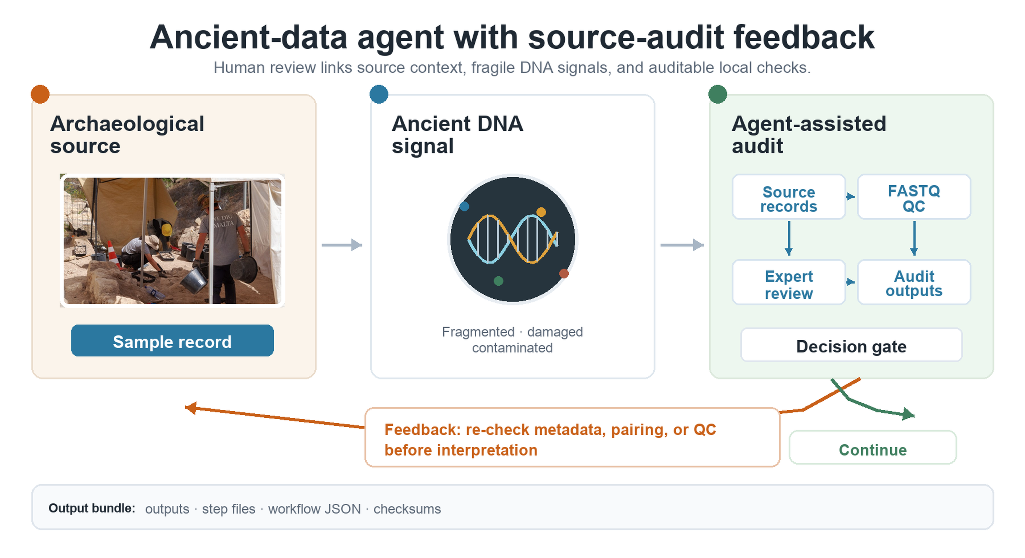
Graphical abstract. PaleoRigor connects archaeological source material, fragile ancient biomolecular evidence, and reviewable local analysis. The term agent-assisted audit in the figure refers to PaleoRigor; it does not imply autonomous biological interpretation. The archaeological excavation photograph was adapted from Godwin Borg, Wikimedia Commons, CC BY-SA 4.0; all other schematic elements were created by the authors. The graphical abstract shows the paleobiological use case, while Figure 1 shows the expert review and local execution steps.

Background
Paleomicrobiome and ancient-human microbiome studies examine archaeological material to investigate past health, diet, and microbial exposure [1–5]. Sequencing data are often deposited in the Sequence Read Archive (SRA) and European Nucleotide Archive (ENA) [6, 7], and community curation has standardised the sample-level metadata that accompanies published ancient metagenomic records [8]. Access to these data is only the starting point for analysis. Researchers must select the intended files, check their local copies, choose appropriate operations, and document subsequent changes. Errors at this stage can persist through an otherwise successful analysis. A traceable connection between the research question, repository record, and local workflow is therefore essential.
These requirements are particularly consequential in ancient biomolecular research, where DNA is often scarce, fragmented, damaged, and contaminated. Authenticity depends on several sources of evidence, including sample history, molecular damage, contamination controls, and archaeological context [3, 9–13], and the field has published explicit protocols for authenticating ancient DNA recovered from metagenomic data [14]. Mapping, adapter removal, and damage analysis assess the files supplied to them [15–18]; they cannot compensate for an incorrect starting file. Source verification therefore supports, but does not replace, biological authentication.
Standardized workflows can reduce manual handling and make complex analyses easier to review. Generic workflow engines support reproducibility once users have specified inputs and operations [19–21], and the ancient-metagenomics community has built domain pipelines on them: aMeta implements profiling and authentication as a Snakemake workflow [22], nf-core/eager implements genome reconstruction in Nextflow [23], HOPS couples pathogen screening to automated authentication [24], and more recent workflows continue to optimise the profiling step itself [25]. Determining whether those choices suit the research question still requires expertise. Language-model agents can now translate a request into such choices directly [26], which removes the need to write the plan by hand but introduces a new failure mode: the plan is generated rather than authored, and may reference files that do not exist, apply operations a format does not support, or assert conclusions the data cannot support. Neither an unconstrained agent nor a workflow engine records why a particular plan was accepted. What is missing is a mechanism that states a proposed analysis explicitly, constrains what it may do before it runs, and preserves the reasoning and evidence afterwards, while leaving responsibility for the biological conclusions with the researcher.
We developed PaleoRigor as a bounded agent for this purpose. Its planner converts a research request into a proposed workflow, and its validator checks file references, formats, and compatibility between steps. Each skill is a predefined local analysis module that the user can inspect; the agent cannot write or execute code outside that registry, so the space of possible actions is fixed before the model is called. After approval, the executor runs the selected skills and saves their intermediate and final outputs. A report links those outputs to the workflow and its execution records. This division allows paleobiologists to review the proposed analysis and assess its results without delegating scientific judgment to the planning model (Figure 1; Tables 1 and 2).
We evaluated workflow execution, data traceability, and the limits of interpretation. A frozen held-out benchmark tested whether supported requests produced the required outputs and whether unsuitable requests were blocked for the correct reason, against an ablation of the system's own planning contract. Three dataset-level cases then examined agreement between local sequencing files and public records, a recorded table transformation, and an expert-defined audit of a retraction-associated record. Together, these tests assess preparation for specialist analysis, rather than ancient-DNA authentication or biological reconstruction.
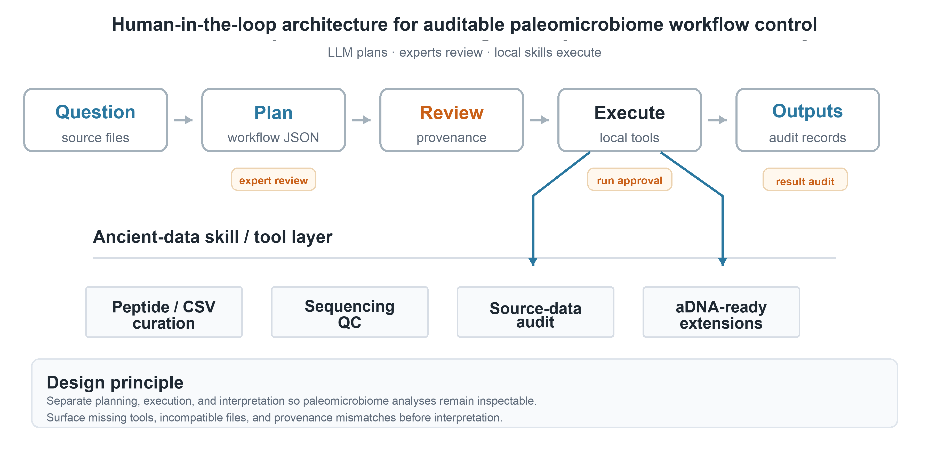
Figure 1. Human-in-the-loop design of PaleoRigor. A paleobiologist starts with a research question and available source material, such as metadata tables, sequencing files, or repository records. PaleoRigor drafts a structured workflow. Experts then review the source, file organization, task fit, and parameters before local execution. Approved skills perform limited tasks such as table cleaning, sequencing quality control, source-record comparison, and evidence packaging. Final outputs are stored separately from step records so that readers can inspect both the result and how it was produced. In the figure, LLM means large language model, and workflow JSON means a machine-readable text record of the proposed plan.
Figure 1 identifies where paleobiologists remain responsible for decisions: defining the question, approving the proposed workflow, and interpreting the retained evidence. Supplementary Table S4 links these checkpoints to the errors they are intended to prevent.

Results

Control layers and the criteria used to test them
PaleoRigor is organised around four risks that precede paleobiological interpretation: ambiguous requests, incorrect source files, undocumented data changes, and conclusions unsupported by the available evidence. Each was observed during development, and each is addressed by a separate control layer rather than by a single safeguard. The planner states the request as an explicit ordered workflow; the validator checks file references and format compatibility; the executor runs only predefined skills; and the reporter stores final outputs separately from the records that explain them (Figure 1; Table 1).
Expert review is placed at three points in that sequence: when the request is framed, before execution, and when the retained evidence is interpreted. Table 1 sets out which layer addresses which risk, and where the paleobiologist rather than the planning model remains responsible for the decision.
Four of these limits are specific to ancient biomolecular work, and are stated to the planner as refusal rules rather than left to the user to remember. Quality-control output cannot establish that reads are ancient or free of contamination, so a request to demonstrate either is refused rather than answered. Damage analysis requires aligned data and an explicitly named reference [15, 18], so it is refused when those prerequisites are absent. Read alignment and host removal are refused when no reference genome or existing index is named, instead of defaulting to one. A request whose file format contradicts the operation is refused rather than silently replaced by a different analysis. Each refusal returns a named reason code, and the rules are reproduced verbatim in Supplementary File 4.

Table 1. PaleoRigor control layers and expert checkpoints. The table shows how planning, validation, execution, output storage, and interpretation are kept separate. This design supports auditable preparation for paleomicrobiome analysis without replacing expert judgment.
Layer | Risk addressed | Control used | Expert intervention
Planner | Ambiguous user intent | Structured workflow JSON | Review proposed steps before running
Validator | Missing outputs or wrong file type | Reference and compatibility checks | Reject or revise invalid workflow
Executor | Uncontrolled code generation | Predefined skills and local tools | Approve local execution
Reporter | Opaque outputs | Final files, step files, records and checksums | Interpret results and boundaries

Table 2 defines six criteria covering workflow validity, file compatibility, source agreement, traceability, software dependencies, and limits on permitted analyses. These criteria were fixed before the evaluation reported below. A supported run passed only if it met every applicable planning, validation, and execution requirement; a boundary run passed only if it stopped with the prespecified reason. Scoring was therefore strict: one unmet requirement failed the run.

Table 2. Engineering tests used to assess PaleoRigor. Each test represents an error seen during development and states how the system should prevent or expose it before biological interpretation. Δreads is the local read count minus the public read count. Rbytes is the local compressed FASTQ size divided by the public fastq_bytes value.
Evaluation target | Metric or rule | Interpretation
Workflow validity | All step inputs must reference uploaded files or earlier outputs | Prevents hallucinated pipeline references
File compatibility | Input format must match skill requirements | Prevents applying FASTQ operations to CSV files
Source agreement | Δreads = 0 and Rbytes = 1 when public metadata are available | Confirms local files match repository records
Traceability | Final outputs plus step outputs and run records | Allows later inspection by users or supervisors
Dependency behavior | Missing tools are reported instead of auto-installed | Keeps execution transparent on user machines
Repeated-run workflow success and boundary control | Supported tasks must pass all tests. Incompatible or overreaching requests must stop before unsafe execution. | Separates repeatable workflows from safe scientific boundaries.

The frozen held-out evaluation and its control-layer ablation
Two qualification rounds preceded the reported evaluation. Each comprised four supported workflows and four boundary requests, repeated three times in both arms, and PaleoRigor passed 18 of 24 runs in v3 and 18 of 24 in v4 (75.0% in each round). Failures arose when declared output names did not match skill outputs, chart-name variants were rejected, and sample-sheet validation required unavailable FASTQ files. These rounds informed corrections to output declarations and planning rules. Because they shaped the system they cannot serve as independent validation of it, and their failures are retained in the reported record (Figure 2A).
We then froze the manifest, inputs, prompts, scoring rules, threshold, and code before the first call, and evaluated the frozen v5 release on held-out material: new files, identifiers, values, and request wording, with four supported and four boundary scenarios repeated three times per arm, producing 24 runs for PaleoRigor and 24 for its control arm.
That control arm was an ablation of the PaleoRigor control layer, not a trial against an external tool. Both arms used the same model, task files, workflow schema, blocked-decision schema, uploaded-file summaries, skill catalogue, call-order protocol, execution path and scoring rules; that shared context was byte-identical at 35,682 characters. The arms differed only in the planning instructions preceding it. The ablated arm received a four-sentence planner instruction of 247 characters. The PaleoRigor arm received the full planning contract of 40,347 characters, comprising thirty staged-workflow and format-compatibility rules, one worked example workflow, and six control-layer rules that name the four boundary reason codes the system is designed to emit. The boundary comparison therefore measures whether an explicitly encoded rule is applied consistently; it does not measure whether a planner identifies a boundary it was not told about. Both system prompts are reproduced verbatim in Supplementary File 4.
PaleoRigor passed 23 of 24 runs (95.8%; Wilson 95% confidence interval, 79.8–99.3%): 11 of 12 supported workflows and 12 of 12 boundary decisions. This exceeded the prespecified threshold of at least 22 of 24. The ablated arm passed 19 of 24 (79.2%; 59.5–90.8%): 9 of 12 supported workflows and 10 of 12 boundary decisions (Figure 2B). The paired difference was 16.7 percentage points; five runs passed only with PaleoRigor and one only with the ablated arm (exact two-sided McNemar p = 0.219), so the comparison did not establish statistical superiority. All 48 outcomes were independently recomputed from the retained records, and all 48 matched the stored labels.
Scenario-level results locate the remaining errors (Figure 2C). PaleoRigor passed 3 of 3 runs for FASTA curation, paired FASTQ quality control, peptide-table processing, and each of the four boundary scenarios, and 2 of 3 runs for metadata-to-sample-sheet preparation. In the failed run the planner omitted the .tsv suffix from an uploaded-file reference, which the validator rejected before execution. The ablated arm passed 1 of 3 runs for both FASTA curation and file-format mismatch decisions, and 2 of 3 peptide-table runs.
Repeating the frozen design with a second planner changed only the requested model. Tasks, files, prompts, validation rules, scoring, tools, call order, and the 24-run sample per arm were unchanged. PaleoRigor passed 24 of 24 runs (100%; Wilson 95% confidence interval, 86.2–100%) and the ablated arm 19 of 24 (79.2%; 59.5–90.8%), a paired difference of 20.8 percentage points with all five discordant pairs favouring PaleoRigor (exact two-sided McNemar p = 0.0625). This met the preregistered criterion of at least 22 PaleoRigor successes and more successes than the ablated arm.
Both configurations therefore met their engineering criteria on the evaluated release and task set. Neither ranked models nor tested generalization across providers, and neither compared the system with external workflow practice; broader reliability requires testing across additional data types, requests, and settings.
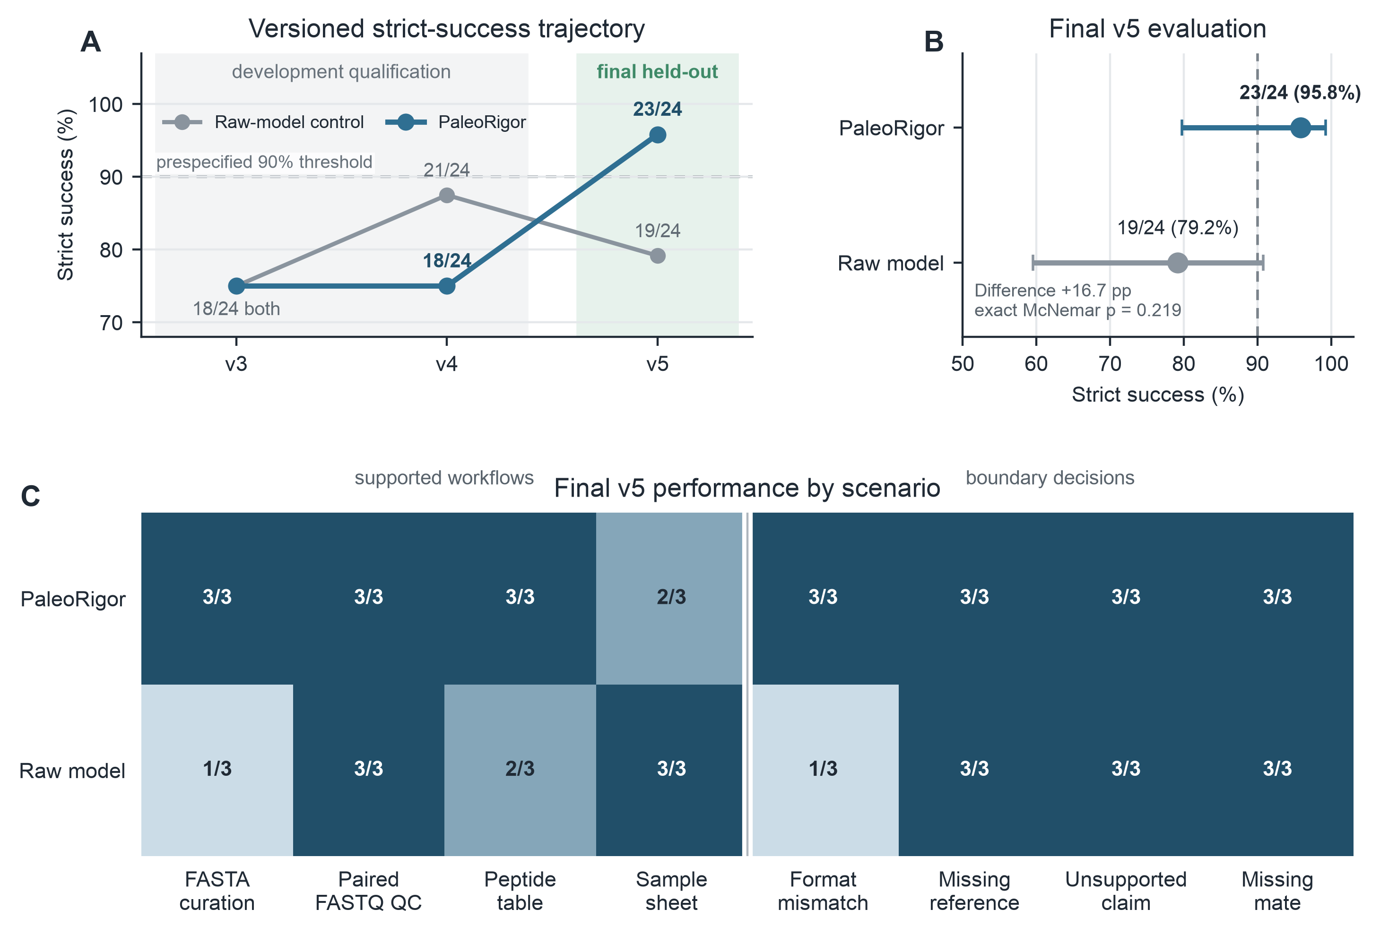
Figure 2. Versioned engineering benchmark and final held-out evaluation. A, Strict run-level success across v3, v4, and v5. V3 and v4 were retained as development-stage qualification rounds; each contained 24 PaleoRigor and 24 ablated-arm runs. The frozen v5 release used new files, values, identifiers, and wording. The dashed line marks the prespecified v5 threshold of more than 90%, operationalized as at least 22 of 24 successful PaleoRigor runs. B, Final v5 strict success for PaleoRigor and for the ablated arm, in which the PaleoRigor planning contract was removed from the same model. Points show observed proportions and horizontal bars show two-sided Wilson 95% confidence intervals. The paired absolute difference was 16.7 percentage points; the exact two-sided McNemar p value was 0.219. C, V5 successes by scenario. Supported workflows comprised FASTA curation, paired FASTQ quality control, peptide-table processing, and sample-sheet preparation. Boundary decisions tested a file-format mismatch, a missing reference, an unsupported authenticity or contamination claim, and a missing paired-end mate. Each cell reports successful runs out of three.

Table 3. Operational comparison of PaleoRigor with existing workflow practices. This is not a head-to-head speed or biological-accuracy benchmark. The measured-outcome column reports results obtained for PaleoRigor in this study. Figure 2 provides a control-layer ablation using the same model with the PaleoRigor planning contract removed; the remaining comparison statements describe common differences in workflow control and were not measured as external software trials.
Workflow-control property | Measured PaleoRigor outcome | Comparison interpretation
Planning validity | Workflows were represented as explicit ordered steps with declared inputs, outputs, parameters, and validation rules before local execution. | Unlike manual command lines or unconstrained large-language-model code, the plan can be inspected before anything runs.
Tabular biological data curation | The peptide validation table was curated from 5,810 rows to 5,696 non-redundant records; 114 duplicate sequence entries were removed. | The result is not only a cleaned table, but a recorded transformation with reusable outputs.
Public FASTQ source-metadata correspondence | Across six public FASTQ records, PaleoRigor-derived read counts matched ENA/SRA metadata with Δreads = 0, and compressed-file ratios were Rbytes = 1.000. | The system quantifies correspondence with intended public records at the tested metadata level before downstream interpretation.
Retraction-associated source audit | For SRR29088443, PaleoRigor generated an auditable source-level report while limiting interpretation to file-level reproducibility. | The audit separates source-data reproducibility from disputed or retracted biological claims.
Output traceability | Each local run exports final_outputs, step_outputs, and ResearchAgent Records containing workflow JSON, manifests, checksums, timestamps, and run reports. | The evidence chain can be reviewed later by users, supervisors, or domain experts.
Repeated-run engineering success | Final v5: PaleoRigor 23/24 strict successes (95.8%) versus 19/24 (79.2%) for the ablated control arm; all 12 PaleoRigor boundary decisions passed. | Shows release-level workflow success and boundary control for the fixed task set, while the nonsignificant paired comparison and wide intervals limit generalization.
Table 3 sets these measured outcomes alongside common properties of existing workflow practice. It is not a head-to-head trial: only PaleoRigor was measured, and the comparison statements describe differences in workflow control rather than results obtained by running other software.

The three dataset-level cases below apply these criteria to material of different kinds: public sequencing records related to ancient and paleomicrobiome research, a tabular transformation whose effect can be checked exactly, and a record whose published interpretation was retracted. Figure 3 examines source agreement, Figure 4 traces a recorded transformation, and Figure 5 shows where file-level evidence stops. Supplementary Tables S1–S3 label these cases by their repository folders — Case 1, the peptide table; Case 2, the sequencing records; Case 3, the retraction-associated audit — following the order in which they were run rather than the order presented here.

Source-record agreement for public sequencing records
This case tested whether local sequencing files agreed with the intended repository records before ancient-DNA interpretation. Six public records related to ancient or paleomicrobiome research were examined. PaleoRigor checked file structure, ran FastQC, summarized reports with MultiQC, calculated SeqKit statistics, and compared local files with ENA/SRA metadata [6, 7, 27–29]. Records retained the accession, sequencing layout, and mate organization; R1 and R2 identify the two paired-end files.
All six records matched public read counts exactly (Δreads = 0), and compressed-file sizes matched repository values (Rbytes = 1; Figure 3A,B). These checks support agreement with the intended records at the metadata level. Read counts and sizes cannot establish byte-for-byte identity or ancient-DNA authenticity. They provide an initial check of source selection before downstream processing [15, 17].
Figure 3 distinguishes source comparison from descriptive quality control. Panels A and B compare read counts and file sizes; panel C reports GC content; panel D summarizes record agreement. These measurements describe the files and their relationship to repository metadata, leaving authenticity and contamination to separate analyses.
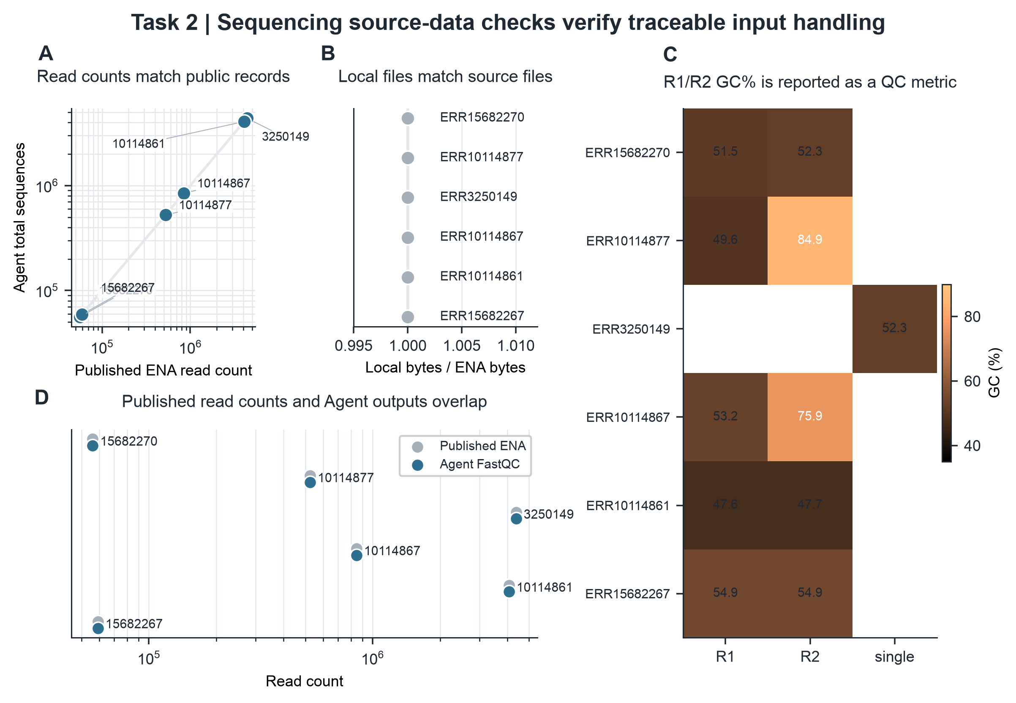
Figure 3. Agreement between local sequencing files and public records. A, Local read counts compared with ENA/SRA read counts. B, Local compressed-file sizes compared with public fastq_bytes values. Δreads is local reads minus public reads. Rbytes is local compressed bytes divided by public fastq_bytes. C, GC content for R1, R2, or single-end files. D, Summary of record agreement across the tested files. Agreement supports a match with the intended public record, but it does not prove byte-level identity, ancient-DNA authenticity, or biological validity.

A recorded transformation of a data table
This case tested whether saved records could explain a change to a data table. We used a peptide table because duplicate removal provides a small, exactly checkable transformation. PaleoRigor standardized columns, checked sequence syntax, removed 114 duplicates from 5,810 input rows, and exported 5,696 unique records (Figure 4A,B). The case assessed general data handling rather than biological interpretation.
The run record attributed the removal of 114 rows to the deduplication step. Class counts and peptide-length distributions provided additional checks for unintended changes (Figure 4C,D). This documented transformation satisfied the traceability criterion in Table 2, without testing peptide biology or ancient-microbiome interpretation.
Figure 4 links the processing steps in panel A to the row-count change in panel B. Panels C and D describe the retained label counts and sequence lengths, allowing the exported table to be reviewed alongside its transformation history.
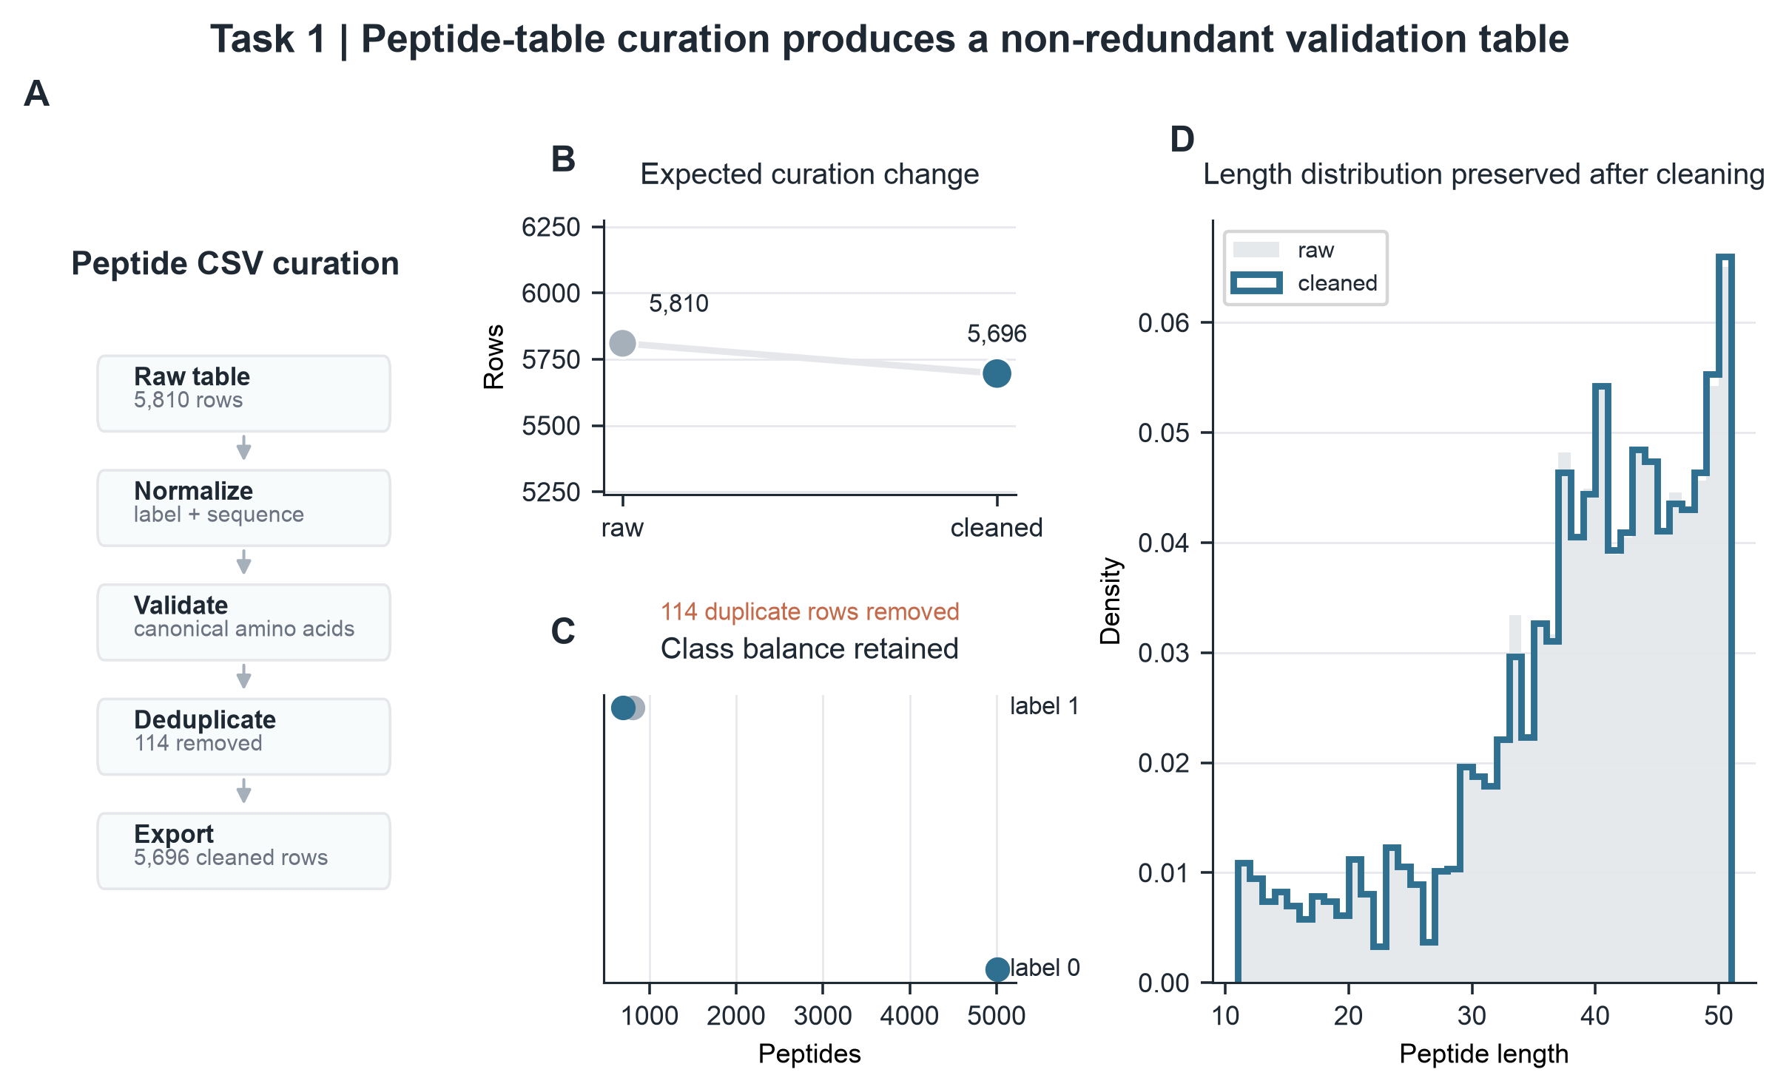
Figure 4. Peptide CSV curation. A, Steps used to process the peptide table. B, Row count before and after duplicate removal, from 5,810 input rows to 5,696 unique records. C, Counts for the two peptide labels before and after cleaning. D, Peptide-length distribution after cleaning, measured as amino-acid residues per sequence.

Expert-defined limits on interpretation for a retraction-associated record
This case examined how expert review could limit conclusions when technically reproducible files were associated with a retracted publication. We selected SRR29088443 from SRP508771 because the SRA study title and submitting center matched the publication record [30, 31]. The accession itself was not marked as retracted. These data originated from a modern clinical microbiome study, so the case tested limits on interpretation rather than ancient-microbiome analysis. The expert restricted the workflow to file-level checks and excluded reassessment of the retracted biological claim (Figure 5A).
Within the approved scope, PaleoRigor reproduced the repository values. Each FASTQ mate contained 53,571 reads, with 26,517,645 bases across both files, and both compressed-file sizes matched the public record. Quality-control summaries reported mean read lengths of 244 and 251 base pairs (bp), with GC contents of 54.0% and 53.6%, respectively (Figure 5B,C). These measurements characterized the available files without testing the biological interpretation of the retracted study.
Figure 5D makes the division of responsibility explicit. The expert supplied the retraction context and defined the permitted analysis; PaleoRigor performed the file checks and retained their outputs. The software did not independently detect or adjudicate the retraction. The case illustrates how expert-defined scope can prevent agreement with repository metadata from being presented as biological validation. The separate boundary tests in Figure 2 assess how reliably the planner followed predefined restrictions.
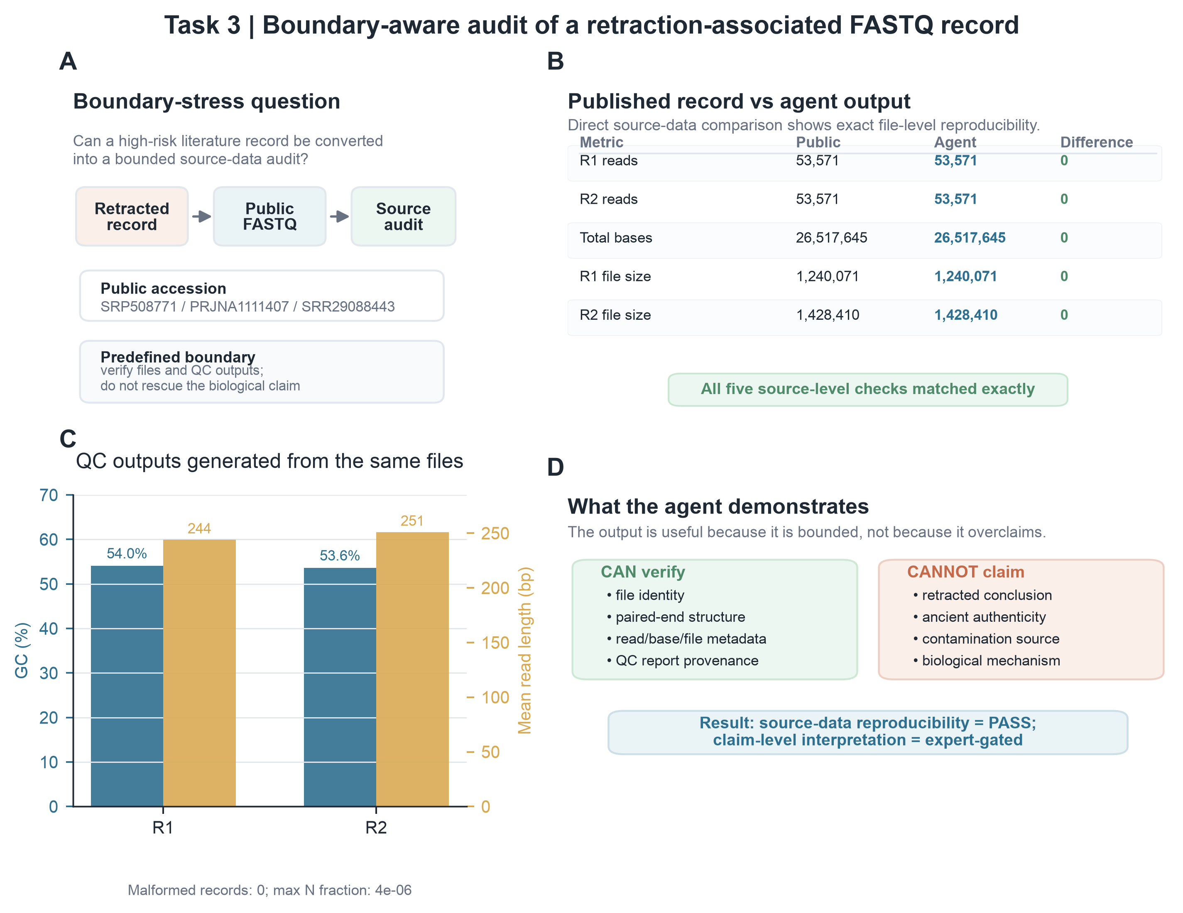
Figure 5. File-level audit of a retraction-associated FASTQ record. Retraction-associated refers to the linked publication context, not to an autonomous retraction decision by PaleoRigor. The modern clinical microbiome record was used as a negative-control test of interpretation boundaries, not as an ancient-microbiome dataset. A, The expert limited the question to a source audit. B, Public metadata and PaleoRigor outputs matched for R1 reads, R2 reads, total bases, and compressed-file sizes. R1 and R2 are paired-end mates. C, Descriptive quality-control results from the same files, including GC content, mean read length, malformed-record checks, and N-fraction. N-fraction is the proportion of bases recorded as N. D, The allowed conclusion was limited to file-level reproducibility and did not validate the retracted biological interpretation.

Packaged applications bundled the tools required for local use
We packaged the system as a self-contained Apple Silicon application for macOS 13 or later, including seven analysis tools and their runtimes. In the release gate recorded on 2026-08-23, all 278 project tests in the test suite passed, and all seven bundled commands returned the expected tool identity or version. The application passed strict ad-hoc signature verification and ran from a mounted, read-only disk image. It also removed its temporary launch-token file after use and stopped the local backend when closed. These results verified packaging on the build and test machine; independent usability testing was still required.
A Windows 10/11 x64 installer is produced by a separate native build workflow from the same backend source. It bundles the same seven analysis tools with an Eclipse Temurin 21 runtime and stores model credentials in Windows Credential Manager; its Samtools build is version 1.24 rather than the 1.23.1 used on macOS. Source URLs and archive checksums for every bundled component are pinned in the repository packaging manifests for both platforms. The Windows build was verified by its automated build and tool-identity checks only; every result reported in this manuscript was produced on macOS.

Discussion
PaleoRigor addresses a practical problem that arises before specialist interpretation: researchers can lose track of which files were analysed and how those files changed. Incorrect inputs, incompatible operations, and undocumented transformations can all produce plausible-looking outputs. By exposing the proposed workflow and retaining the resulting records, PaleoRigor is designed to make these decisions reviewable before the outputs are used to support biological claims.
The benchmark supports a narrow and specific claim. With the planning contract in place, the system produced valid, executable workflows and returned the prescribed refusal in every boundary case, and removing that contract from the same model degraded both outcomes under otherwise identical conditions. What the benchmark cannot support is any statement about unfamiliar task types, other providers, or performance relative to established workflow practice: the comparison was internal by construction, and the paired tests did not reach significance at 24 runs per arm.
The dataset cases show what traceability adds beyond a run that merely completes. A successful run establishes only that the software did something; the retained records establish which file it acted on and what changed, and both remained recoverable after the fact. That distinction matters most at the point where it is hardest to check by eye — when a researcher decides whether the material is worth interpreting at all — and it is the reason the evidence trail, rather than the success rate, is the part of this system intended to be reused.
The boundary behaviour and the retraction-associated case address one risk from two directions. The benchmark tests whether the system applies refusal rules it has been given; the case shows an expert narrowing the permitted conclusion further than anything the system encodes. Neither is sufficient alone. Encoded rules cannot anticipate an unfamiliar claim, and expert scoping does not scale beyond the analyses an expert personally reviews. The claim made here is only that the two together keep the boundary visible, not that they enforce it.
For paleobiologists, the practical value is a starting point that can be checked before more demanding analyses proceed. Source and workflow review can precede adapter removal, damage analysis, host removal, taxonomic profiling, contamination assessment, and statistical interpretation [15, 17]. Retaining intermediate evidence allows experts to revisit a choice, identify an error, or reject an analysis while preserving its connection to the original question.
Further evaluation should reflect the uncertainty of archaeological samples more closely. Controlled mixtures could include known amounts of endogenous, environmental, handling, and laboratory material. Such tests could assess whether PaleoRigor selects appropriate controls and declines unsupported authenticity claims across contamination levels [32–35]. This would extend evaluation from executing defined tasks to handling uncertainty in ancient biomolecular research.
Additional negative controls would help test the limits of this approach. Retracted or disputed studies and low-biomass datasets affected by reagent contamination offer relevant examples [33, 35]. The present case demonstrates an expert-defined restriction, while the benchmark evaluates responses to predefined boundary categories. Neither establishes how the system would respond to unfamiliar claims, mixed contamination sources, or incomplete archaeological metadata.
Practical adoption also requires accessible software and inspectable records. The repository retains requests, workflows, intermediate files, checksums, reports, figure sources, and environment details (Supplementary Tables S1–S6). The public website [36] explains the method and its safeguards. The Apple Silicon application opens a local browser interface and includes seven analysis tools with their required runtimes. Users can review and run workflows without separately installing Python, Conda, Java, or the bundled tools. Whether this packaging improves usability for paleobiologists remains a question for independent user testing.

Limitations
The present evidence concerns workflow execution, traceable transformations, and agreement with repository metadata. The frozen v5 task set achieved a 95.8% strict-success rate, but this does not establish ancient-DNA authentication, contamination-source identification, or microbial ecological reconstruction. Table 3 compares operational features; the ablated arm evaluates the planning contract rather than biological accuracy against a complete pipeline. The peptide case tests general table handling, and the retraction-associated case uses modern clinical data. The reported evaluation used the Apple Silicon macOS application for macOS 13 or later; a Windows 10/11 x64 build exists but produced no reported result, so cross-platform equivalence remained outside this evaluation. No user evaluation of any kind was conducted: the system was operated only by its developers, so every statement about what it offers its intended users describes its design rather than a measured outcome, and its installability, learnability and interpretability for researchers without computational training remain untested. Larger ancient-data panels, controlled contamination mixtures, comparisons with established workflows, and independent user evaluation are needed to assess wider scientific use.
The benchmark was small and used two models from one provider within a single local software environment. Each comparison included 24 runs per arm across eight scenario types, yielding wide confidence intervals. The paired difference was 16.7 percentage points for V4-Flash (exact McNemar p = 0.219) and 20.8 percentage points for V4-Pro (p = 0.0625). All five discordant Pro pairs favored PaleoRigor, but neither test met the 0.05 significance threshold. These results met the engineering criterion without establishing general superiority. Both earlier rounds achieved 75.0% and informed development, so v3 and v4 cannot provide independent validation of v5. Larger preregistered evaluations should include other providers, environments, unfamiliar errors, and scientific claims.
The control arm is an ablation, not an external baseline. Because the PaleoRigor planning contract names the four boundary reason codes explicitly, the 12 of 12 boundary result shows that the encoded control layer is applied consistently; it does not show that the system infers scientific boundaries independently. Separating those two effects would require a third arm that receives the boundary rules but not the workflow-staging rules, which was not run. Comparison with manual command-line practice, fixed standard operating procedures, or established workflow engines such as Snakemake and Nextflow also remains outstanding. Until such comparisons are available, these results support the internal design claim rather than a claim of advantage over current practice.

Conclusions
PaleoRigor makes the path from a research request and its source files to recorded analysis outputs available for inspection. The frozen release passed 23 of 24 held-out runs, including all 12 boundary decisions, compared with 19 of 24 for the ablated arm. Six public sequencing records matched repository read counts and compressed-file sizes, and the removal of 114 duplicate table rows was documented. These findings support its use for workflow review and evidence preparation within the tested scope, as exercised by its developers. Independent benchmarks, comparisons with established workflow practice, controlled contamination tests, ancient-DNA-specific checks, user evaluation with the researchers the system is intended for, and community-maintained skills are needed to establish broader applicability. By preserving the context of computational decisions, PaleoRigor provides a basis for specialist review of fragile microbial evidence.

Methods

Agent workflow representation
A user request was represented as an ordered workflow W containing n executable steps:
W = {s₁, s₂, …, sₙ}
Each step sᵢ was defined by a skill identifier kᵢ, input references Iᵢ, output declarations Oᵢ, parameters θᵢ, and a natural-language reason rᵢ:
sᵢ = (kᵢ, Iᵢ, Oᵢ, θᵢ, rᵢ)
The workflow representation records source files, intended outputs, parameters, and reasons before any analysis runs. Each skill identifier refers to a predefined module that can be inspected independently of the planning model. This extends established reproducible-workflow principles with a natural-language planning and review stage [19–21, 37]. Figure 1 relates the representation to Plan, Review, Execute, and Outputs; Table 1 identifies responsibility at each stage.

Workflow validation
The validator evaluated a proposed workflow W against the available uploaded files F and the available skill registry K:
V(W, F, K) → {0, 1}
Acceptance required three conditions: each step used a registered skill, each input referred to an uploaded file or an earlier output, and input formats matched the skill:
Iᵢ ⊆ F ∪ O<ᵢ
format(Iᵢ) ∈ compatible(kᵢ)
These checks identify missing outputs, unresolved references, and incompatible file types before execution. Supplementary Table S5 links the observed errors to the corresponding checks. Because valid references and formats do not establish that a scientific claim is justified, requests exceeding the permitted scope were evaluated separately.

Execution environment and implemented skills
Validated steps were executed through predefined local skills. Each skill wrapper connected a workflow step to a tool and recorded inputs, parameters, outputs, warnings, and errors. Table skills standardized peptide CSV files, checked sequences, removed duplicates, and exported cleaned tables. Sequencing skills supported file detection, pairing checks, FastQC, MultiQC, SeqKit statistics, and source audits. External tools ran in configured environments; missing software was reported to the user without automatic installation. Figures 3–5 show outputs from these operations [27–29], and Supplementary Table S6 records the software environment.

Human-in-the-loop checkpoints
Experts reviewed the analysis at three stages. At intake, they checked whether the request addressed the scientific question. Before execution, they approved, revised, or rejected the proposed workflow and its dependencies. Afterwards, they assessed final and intermediate outputs to decide whether further biological analysis was justified. Figure 1 and Supplementary Table S4 show the decisions assigned to each checkpoint.

Scope and non-goals
PaleoRigor was designed to support workflow review, execution, and documentation. Its checks cover repository metadata, file compatibility, workflow references, quality-control outputs, and run records. Metadata agreement alone cannot establish byte-level identity, ancient-DNA authenticity, contamination sources, microbial ecology, or the validity of a retracted claim. Experts remain responsible for archaeological interpretation. Figure 5D illustrates the scope of a permitted conclusion, and Task 6 tests adherence to that scope.

Engineering benchmark protocol
Each benchmark round used a fixed paired design with eight scenarios: four supported workflows and four boundary requests. Three repetitions per scenario in each arm produced 24 runs per arm and 48 API calls per round. The arms used the same model configuration, with calls made in alternating order. Both arms received the same workflow schema, blocked-decision schema, uploaded-file summaries and skill catalogue; this shared block was byte-identical at 35,682 characters. The ablated arm received, in addition, only a four-sentence planner instruction of 247 characters. The PaleoRigor arm received the full planning contract of 40,347 characters, comprising thirty rules governing workflow stages, file compatibility, prerequisites and declared outputs, one worked example workflow, and six control-layer rules that state the four boundary reason codes together with the limits on scientific claims. Supported workflows were executed locally; boundary requests were evaluated as decisions and were never executed.
PaleoRigor passed 18 of 24 runs in each of v3 and v4, which were retained as failed qualification rounds. Their failures informed development and were not reclassified as confirmatory successes. Before v5, we corrected output-name mapping, FASTA/FASTQ suffix handling, peptide-statistics declarations, chart aliases, and metadata-only sample-sheet planning. We froze the v5 manifest, inputs, prompts, scoring rules, threshold, and code before the first API call. V5 used new files, identifiers, values, and wording, with a fixed sample size and no selective reruns or replacement of failures.
For each run r and required criterion d, qᵣ,d was 1 when the run passed the stated rule and 0 when it failed. Supported-run criteria covered parsing, required and forbidden skills, production workflow validation, and local execution. Boundary runs required a valid blocked response with the prespecified reason code. A run passed only when every relevant rule passed:
Rᵣ = ∏d∈Dᵣ qᵣ,d
For task t with nₜ repeated runs, the pass rate was calculated as:
p̂ₜ = (1/nₜ) Σr∈t Rᵣ
Strict-success proportions are reported with two-sided Wilson 95% confidence intervals. The prespecified v5 criterion required at least 22 of 24 PaleoRigor runs to pass, exceeding 90%. Paired differences were reported in percentage points and assessed with an exact two-sided McNemar test; this secondary comparison had limited power with 24 pairs. Each v5 label was independently recomputed from its retained response, workflow or blocked decision, validation result, and execution record. All 48 labels matched. Manifests, scores, summaries, and Figure 2 source data are retained under analysis/benchmark_v3, analysis/benchmark_v4, analysis/benchmark_v5, and Final data/manuscript_figures/benchmark_v5.
For the second-model check, we reused the frozen v5 design and changed the requested model from DeepSeek-V4-Flash to DeepSeek-V4-Pro. The eight scenarios, three repetitions, two arms, prompts, temperature (0), thinking mode, and JSON response mode were unchanged. Validation, scoring, local execution, and the fixed denominator were also retained. The Pro hypothesis and decision rule were committed before the first formal call. The criterion required at least 22 of 24 Pro/PaleoRigor successes and more successes than Pro/raw. Recomputing all 48 Pro labels from retained records confirmed every label; no API call failed. The previously observed Flash results provided descriptive context only.
A third model configuration, deepseek-v4-flash-vision-exp, was also run against the frozen v5 design on 21 August 2026, but the experiment was not completed: only the ablated arm was executed (17 of 24 successes, 70.8%; Wilson 95% confidence interval, 50.8–85.1%). No matched PaleoRigor arm was run, so this configuration yields no paired comparison and contributes no result to the present manuscript. Its manifest, run records and summary are retained in the repository and are reported here so that the retained evaluation materials can be reconciled with the results presented above.

Planning-model configuration
All planning calls used the OpenAI-compatible chat-completions endpoint of the model provider. Each request set the sampling temperature to 0, enabled the provider's extended-reasoning mode, and required a JSON object response, with a 120 s per-request timeout. Transport and HTTP errors were retried up to twice with exponential backoff capped at 4 s. When a returned object failed schema validation, the planner issued exactly one repair call that resupplied the original system prompt together with the validation errors and the invalid object, and instructed the model to correct the JSON without changing the intended task; a second failure aborted the run. In the reported evaluations no request required a retry and no completion required a repair call: all 48 v5 runs and all 48 second-model runs succeeded on the first attempt. The provider exposes no sampling seed, so individual runs are not bit-reproducible.
The frozen v5 evaluation used deepseek-v4-flash and ran on 19 August 2026 between 02:34 and 02:50 UTC at repository commit 4be5f2f. The preregistered second-model check used deepseek-v4-pro and ran on 19 August 2026 between 06:52 and 07:14 UTC at commit 728a226. The only change to the evaluation code between those commits was the addition of per-model configuration loading; the scenarios, prompts, schemas, scoring rules and agent source were unchanged. Each run stores a provenance record containing the arm, start and end times, the model string reported by the interface, token usage, latency, attempt count, repair-call count and the repository commit. The complete system prompts for both arms are reproduced in Supplementary File 4.

Source-level agreement metrics
Read-count and compressed-file-size agreement were calculated against public ENA/SRA metadata:
Δreads = Nagent − Npublic
Rbytes = Blocal / Bpublic
Agreement at the measured metadata level required Δreads = 0 and Rbytes = 1. Here, Δreads denotes the difference between local and public read counts; Rbytes is the ratio of local compressed FASTQ size to public fastq_bytes. Run records retained accessions, library layout, and mate organization. R1 and R2 denote paired-end mate files, while single denotes a single-end file. Figure 3 applies these measures to the sequencing panel, and Figure 5B applies them to the retraction-associated case. They measure repository agreement rather than biological validity.
ENA's filereport service publishes an MD5 checksum for each submitted FASTQ file. Because the public sequencing files were not retained after analysis, checksums were not recomputed here, and agreement is therefore reported at the metadata level only. Δreads and Rbytes cannot exclude different content of identical read count and compressed length. A cryptographic checksum comparison should be the primary source-identity metric in future releases, with Δreads and Rbytes retained as secondary descriptors.

FASTQ quality-control summaries
FASTQ summaries included GC percentage, mean read length, and the fraction of bases recorded as N. For a FASTQ file with N reads and read lengths Lⱼ, the measures were:
GC(%) = (G + C) / (A + T + G + C + N) × 100
L̄ = (1/N) Σⱼ Lⱼ
fN = Nbases,N / Nbases,total
FastQC and MultiQC generated standard quality-control files [27, 28]. SeqKit produced short file-level summaries used in the figures [29]. GC content and mean read length in Figures 3C and 5C describe the files; they are not evidence of ancient-DNA authenticity.

Dataset-level evaluations and rigor criteria
The evaluation comprised three versioned benchmark rounds and three dataset-level case studies (Table 4). V3 and v4 informed development, whereas v5 evaluated the frozen release on held-out inputs. The peptide table tested whether data changes were recorded, and the six-record FASTQ panel tested agreement with public metadata. The retraction-associated case examined an expert-defined limit on interpretation. Outcomes included strict workflow success, correct blocking decisions, duplicate removal, table structure, read counts, compressed-file sizes, and descriptive quality-control measures.
Table 4. Datasets and measured results used in the evaluation. The table lists each input, its public source, the PaleoRigor task, and the measured output or required boundary. Public accessions identify the source data. The reported values show what was reproduced without making a biological claim.
Evaluation dataset | Input and original source | PaleoRigor task | Quantitative readout or expected boundary
Peptide CSV curation | Headerless local Validation.csv peptide table; 5,810 rows. Project repository [38] | Normalize columns, validate peptide sequences, remove duplicate sequences, compute summaries and export a cleaned table. | 5,696 non-redundant records exported; 114 duplicate sequence entries removed; label balance and peptide-length distribution retained as figure checks.
Public FASTQ source-QC panel | Six public sequencing records: ERR15682270, ERR10114877, ERR3250149, ERR10114867, ERR10114861 and ERR15682267. Original ENA accessions listed above [6, 7] | Confirm local files match intended ENA/SRA records before downstream analysis; generate FastQC, MultiQC and seqkit summaries. | PaleoRigor-derived read counts matched public metadata with Δreads = 0; local compressed-file ratios were Rbytes = 1.000; GC content and mean read length were reported as QC metrics.
Retraction-associated boundary audit | Paired FASTQ record SRR29088443 from SRP508771 / PRJNA1111407; 53,571 reads per mate and 26,517,645 total bases. Original SRA and BioProject accessions listed above [6] | Test whether a problematic literature-linked record can be converted into a source-data audit without validating the retracted biological claim. | R1 reads, R2 reads, total bases, R1 file size and R2 file size matched the public record exactly; biological interpretation was treated as expert-gated.
Engineering benchmark | Versioned v3–v5 benchmark; each round used eight scenarios, three repeats, and matched PaleoRigor/raw-model arms (24 runs per arm). | Test strict workflow success, local execution, input/scientific boundaries, and the effect of the PaleoRigor control layer under fixed model settings. | V3: 18/24; v4: 18/24; frozen v5: PaleoRigor 23/24 (95.8%) and the ablated arm 19/24 (79.2%). V5 boundary decisions: 12/12.

Output organization, public website and packaged desktop applications
Each local run created a dated result folder. final_outputs contained the files requested by the user. step_outputs contained intermediate files. ResearchAgent Records contained workflows, manifests, checksums, times, and reports. This structure keeps both the requested result and the evidence used to produce it. The public website [36] explains the method and installation process; it does not accept research data or run workflows. Real analyses run locally in the browser interface, where users review the workflow, approve execution, monitor progress, and inspect the report. For the macOS research prototype, this interface is launched by a self-contained Apple Silicon application targeting macOS 13 or later. The application bundles the PaleoRigor backend together with FastQC 0.12.1, MultiQC 1.35, SeqKit 2.13.0, SeqTk 1.5-r133, Samtools 1.23.1, BWA 0.7.19-r1273, Bowtie2 2.5.5, and their required runtimes. Users therefore do not need to install VS Code, Python, Conda, Homebrew, Java, or these seven tools separately. The backend binds only to the local loopback interface, uses a temporary per-launch authentication token, and stores model API credentials in macOS Keychain rather than in the application bundle. The Windows installer exposes the same local browser interface from the same backend source, bundles the same seven tools with an Eclipse Temurin 21.0.8+9 runtime, and stores model credentials in Windows Credential Manager instead.

Reproducibility bundle and supplementary materials
Each case retained final outputs, intermediate files, and run records. Public sequencing files were not duplicated in the repository; their accessions and metadata identify the ENA/SRA records for retrieval. The repository contains processed outputs, workflows, quality-control summaries, manifests, checksums, and plotting scripts. It also includes the v3–v5 benchmark manifests, the preregistered V4-Pro check, run-level scores, summaries, verification reports, and Figure 2 source data. Supplementary Tables S1–S3 link the reported results to these records.
The evaluation was designed to be reconstructible rather than merely described. The hypothesis, decision rule, scenario manifest, input files, prompts, scoring rules and success threshold were committed before the first formal API call of each round, and the preregistrations are kept in the repository. The scenarios themselves were held out: the frozen round used files, identifiers, values and request wording that had not been seen during development, and no run was repeated or replaced after the fact. Every run writes a provenance record containing its arm, start and end times, the model string the interface reported, token usage, latency, attempt count, repair-call count and the repository commit, alongside the verbatim request, the returned plan or blocked decision, the validation result and the execution record. From those records all 96 run labels across the two model configurations were independently recomputed, and all 96 matched. Failed development rounds were retained rather than removed. The software environment is pinned, the analysis outputs carry checksums, and the release corresponding to these results is archived under a permanent identifier. A reader who disagrees with a reported number can therefore recompute it from the deposited records without rerunning the language model, whose outputs are not bit-reproducible.
The supplementary package organizes six evidence tables alongside workflows, run reports, source manifests, and figure data with plotting scripts. It distinguishes public records from local inputs, intermediate outputs, final results, and manuscript figures, allowing readers to trace reported values to their supporting files.

Supplementary Information
The Supplementary Information contains six evidence tables and four file groups. Supplementary Table S1 links each case to final outputs, intermediate files, and run records. Supplementary Tables S2–S6 cover case evidence, claim-to-evidence links, expert checkpoints, error controls, and software settings. Supplementary File 1 contains workflows, reports, manifests, and checksums. Supplementary File 2 contains figure data and scripts. Supplementary File 3 contains example final_outputs and step_outputs. Supplementary File 4 contains the verbatim system prompts sent to both benchmark arms, together with the byte-identical shared contract and the content unique to each arm. Together, these materials support Figures 1–5 and Tables 1–4 without making the main text too long.
Supplementary Table S1. Links to final outputs, intermediate files, and run records. final_outputs contains requested result files. step_outputs contains files produced by each workflow step. ResearchAgent Records contains workflow JSON, manifests, timestamps, checksums, and reports. Each row links a case or sequencing record to the repository folder used to review its evidence trail.
Validation item | Result folder | Repository location | Evidence role
Case 1: peptide CSV curation | Final data/1 | PaleoRigor repository path: Final data/1 [38] | Cleaned CSV, peptide statistics, charts, normalization/validation/deduplication step outputs, workflow manifest and report. Subfolders at this repository location contain final_outputs, step_outputs and ResearchAgent Records.
Case 2a: ERR15682270 R1 | Final data/2 | PaleoRigor repository path: Final data/2 [38] | FASTQ file typing, FastQC/MultiQC outputs, quality-gate report and run records for mate R1. Subfolders at this repository location contain final_outputs, step_outputs and ResearchAgent Records.
Case 2b: ERR15682270 R2 | Final data/3 | PaleoRigor repository path: Final data/3 [38] | FASTQ file typing, FastQC/MultiQC outputs, quality-gate report and run records for mate R2. Subfolders at this repository location contain final_outputs, step_outputs and ResearchAgent Records.
Case 2c: ERR10114877 paired FASTQ | Final data/group 4-5 new | PaleoRigor repository path: Final data/group 4-5 new [38] | Paired-end FASTQ QC outputs and source-record audit records after rerun with corrected inputs. Subfolders at this repository location contain final_outputs, step_outputs and ResearchAgent Records.
Case 2d: ERR3250149 single FASTQ | Final data/6 | PaleoRigor repository path: Final data/6 [38] | Single-end FASTQ QC outputs, source-record checks and local run records. Subfolders at this repository location contain final_outputs, step_outputs and ResearchAgent Records.
Case 2e: ERR10114867 paired FASTQ | Final data/group 7 new | PaleoRigor repository path: Final data/group 7 new [38] | Paired-end FASTQ QC outputs and source-record audit records after rerun with corrected inputs. Subfolders at this repository location contain final_outputs, step_outputs and ResearchAgent Records.
Case 2f: ERR10114861 paired FASTQ | Final data/8 | PaleoRigor repository path: Final data/8 [38] | Paired-end FASTQ QC outputs, metadata checks and run records. Subfolders at this repository location contain final_outputs, step_outputs and ResearchAgent Records.
Case 2g: ERR15682267 paired FASTQ | Final data/9 | PaleoRigor repository path: Final data/9 [38] | Paired-end FASTQ QC outputs, metadata checks and run records. Subfolders at this repository location contain final_outputs, step_outputs and ResearchAgent Records.
Case 3: retraction-associated audit | Final data/retracted_result | PaleoRigor repository path: Final data/retracted_result [38] | Boundary-aware source-data audit, seqkit/FastQC/MultiQC summaries, intermediate step outputs and run records. Subfolders at this repository location contain final_outputs, step_outputs and ResearchAgent Records.
Engineering benchmark | analysis/benchmark_v3; analysis/benchmark_v4; analysis/benchmark_v5 | PaleoRigor repository path: analysis/benchmark_v5 [38] | Versioned manifests, preregistrations, run-level scores, summary JSON, verification report, and Figure 2 source data; complete raw run bundles are retained in the project archive.

Supplementary Table S2. Evidence files for each validation workflow. The table links each case to its natural-language request, workflow records, final outputs, and intermediate files.
Case | Task and workflow evidence | Final-output evidence | Intermediate evidence
Case 1 peptide CSV curation | Natural-language peptide-table curation request; workflow JSON and report in ResearchAgent Records. | cleaned CSV, statistics and charts; GitHub result-folder URL listed in Supplementary Table S1 | normalization, validation, statistics, deduplication and export step outputs; GitHub result-folder URL listed in Supplementary Table S1
Case 2 public FASTQ source-QC panel | FASTQ source-check and QC requests for ERR15682270, ERR10114877, ERR3250149, ERR10114867, ERR10114861 and ERR15682267. | FastQC/MultiQC summaries and metadata JSON files; GitHub result-folder URLs listed in Supplementary Table S1 | per-record step_outputs and ResearchAgent Records; GitHub result-folder URLs listed in Supplementary Table S1
Case 3 retraction-associated audit | Boundary-aware audit request for SRR29088443; workflow report documents that source-data reproducibility rather than biological validity was tested. | audit summaries and QC outputs; GitHub result-folder URL listed in Supplementary Table S1 | file detection, FastQC, MultiQC, seqkit and run records; GitHub result-folder URL listed in Supplementary Table S1
Engineering benchmark | Versioned v3–v5 manifests, preregistrations, raw completions, workflows or blocked decisions, validation/execution records, and independent scoring outputs. | v5 run_level.csv, summary.json, verification_report.md, Figure 2 source data, and SVG/PDF/PNG/TIFF exports. | V3–v5 records are under analysis/benchmark_v3, analysis/benchmark_v4, analysis/benchmark_v5, and Final data/manuscript_figures/benchmark_v5.

Supplementary Table S3. Links between manuscript claims and evidence. Each claim is paired with the file or record that supports it.
Manuscript claim | Primary evidence file or record | Figure/Table location | Repository route
Peptide table curation removed 114 duplicate sequence entries and exported 5,696 non-redundant records. | cleaned_Validation.csv, peptide_statistics.json and deduplication step outputs. | Figure 4; Table 4 | Case 1 result-folder URL in Supplementary Table S1
Public FASTQ source records matched local inputs at the read-count and compressed-file-size level. | fastqc_run_metadata.json, file_type_report.json, MultiQC output and run records for Cases 2a-2g. | Figure 3; Table 4 and Supplementary Table S1 | Case 2a-2g result-folder URLs in Supplementary Table S1
The retraction-associated case reproduced source-level metadata without validating the retracted biological conclusion. | seqkit_stats.tsv, fastqc_run_metadata.json, workflow report and boundary-aware audit figure source data. | Figure 5; Table 4 and Supplementary Tables S1–S2 | Case 3 result-folder URL in Supplementary Table S1
The system separates user-facing final outputs from intermediate step outputs and run records. | Timestamped result folders containing final_outputs, step_outputs and ResearchAgent Records. | Supplementary Table S1 | Repository result folders listed in Supplementary Table S1
Workflow validation prevents unsupported execution such as missing step outputs or incompatible file-type operations. | Workflow validation errors and development failure cases documented in run records and failure-mode audit. | Table 2 and Supplementary Table S5 | ResearchAgent Records listed through Supplementary Table S1 result-folder URLs
The frozen final release exceeded the prespecified strict-success threshold, while earlier qualification failures remained visible. | v3–v5 manifests and summaries; v5 run_level.csv, summary.json, verification_report.md, and retained execution records. | Figure 2; Table 3 | analysis/benchmark_v3, analysis/benchmark_v4, analysis/benchmark_v5, and Figure 2 source-data folders

Supplementary Table S4. Expert checkpoints. The table shows where expert review occurs and which error each checkpoint is intended to prevent.
Workflow stage | PaleoRigor action | Human decision | Failure prevented
Task intake | Converts natural-language request into structured workflow steps with declared inputs, outputs and parameters. | Check whether the planned task matches the scientific question before execution. | Wrong task framing or use of an irrelevant skill.
Pre-execution validation | Checks file references, step-output dependencies and input-format compatibility. | Approve, revise or reject the proposed workflow. | Hallucinated step references, CSV/FASTQ mismatch or unsupported operation.
Local execution | Runs only predefined skills and reports progress, warnings and missing environment dependencies. | Decide whether to install missing tools or stop the run. | Silent auto-installation, uncontrolled code execution or hidden dependency failure.
Post-run review | Exports final_outputs, step_outputs and ResearchAgent Records. | Interpret outputs and decide whether downstream biological analysis is justified. | Treating QC/source checks as biological validation.
Boundary cases | Flags source-level reproducibility separately from claim-level interpretation. | Gate contested or contamination-sensitive conclusions for domain review. | Overclaiming from low-biomass or retraction-associated records.

Supplementary Table S5. Errors and implemented controls. Development failures were kept because they show why each safety check was needed.
Observed failure mode | How it appeared | Implemented control | Evidence route
Missing step-output reference | Generated workflow referred to outputs such as step_02:qc_zip or step_01/normalized that the validator could not resolve. | Strict step-output reference validation before execution. | workflow validation run records
Wrong input type for requested operation | FASTQ QC was requested for a CSV upload, or gzip decompression was proposed for an already FASTQ-classified file. | File-type detection and skill compatibility checks block incompatible workflows. | workflow records and file-type compatibility checks
Quality gate stopping on expected duplicates | The peptide validation file contained duplicate sequences, causing a strict gate to fail before deduplication. | Deduplication and quality-gate order clarified; warnings can be audited before downstream use. | Case 1 step_outputs and deduplication records
Tool-output directory assumption | FastQC initially failed when its output directory was not created before execution. | Skill wrapper creates required output directories and records tool metadata. | FASTQ final_outputs and tool metadata
User prompt/file-name mismatch | A rerun failed when the natural-language prompt still named files from a previous group. | Workflow review exposes uploaded-file references before local execution. | corrected rerun records

Supplementary Table S6. Software and environment details. The table lists the local software used to generate the evaluation outputs and figures. The final release should fix these versions in a tagged manifest.
Component | Version, environment and original URL | Role in study | Release note
PaleoRigor project | Repository: PaleoRigor GitHub repository [38]; release tag v0.2.0, commit 4febac7. | Workflow planning, validation, local skill execution and output organization. | Archived as a tagged GitHub release with Zenodo DOI 10.5281/zenodo.22912729.
Python runtime for manuscript scripts | Python 3.13.9 in project virtual environment; Python: Python website [39]; pandas: pandas website [40]; matplotlib: Matplotlib website [41] | Figure source-data processing and manuscript figure generation. | Used with pandas 2.3.3 and matplotlib 3.11.0.
FastQC | FastQC v0.12.1; software reference [27] | FASTQ quality-control reports for source-QC and boundary-audit cases. | Called through predefined fastq_qc skill; reports preserved in final_outputs.
MultiQC | MultiQC v1.35 in multiqc_env; software reference [28] | Aggregation of FastQC reports into summary HTML/metadata outputs. | Missing environment is reported rather than silently installed.
SeqKit | SeqKit v2.13.0 in base environment; software reference [29] | Compact FASTQ statistics and source-level summaries. | Used for read/base/length checks where available.
Repository and archive plan | GitHub repository: PaleoRigor GitHub repository [38]; archived release: Zenodo DOI 10.5281/zenodo.22912729 | Stable access to code, outputs, step files, run records and figure source data. | Reported results correspond to release v0.2.0; cite the archived snapshot rather than the mutable main branch.

Supplementary note: Figure generation and image provenance
All figures were produced from author-created vector schematics or Python-based plots of analytical outputs. The graphical abstract incorporates an openly licensed archaeological photograph with attribution. No figure was generated with a text-to-image model. Figure 2 was generated in Python from the retained v3–v5 benchmark summaries and run-level records. Its source-data CSV, plotting script, and editable SVG, PDF, PNG, and TIFF exports are preserved with the supplementary analysis materials.

Declarations

List of abbreviations
aDNA, ancient DNA; API, application programming interface; bp, base pairs; CI, confidence interval; ENA, European Nucleotide Archive; GC, guanine–cytosine; JSON, JavaScript Object Notation; LLM, large language model; QC, quality control; SOP, standard operating procedure; SRA, Sequence Read Archive.

Ethics approval and consent to participate
Not applicable. This study performed secondary computational analyses of public repository records and small example files and did not recruit participants, collect new human or animal material, or generate new human-subject data.

Consent for publication
Not applicable.

Availability of data and materials
The datasets analysed in this study are public repository records or small example files. Public sequence inputs are identified by accession in Table 4. Evaluation manifests, run-level scores, workflows, blocked decisions, execution records, processed outputs, figure source data, and plotting scripts are available in the PaleoRigor repository [38]. Large public FASTQ files were not duplicated in the repository; their accession identifiers enable retrieval from ENA or SRA [6, 7].
Project name: PaleoRigor. Project home page: PaleoRigor project website [36]. Source code: GitHub repository [38]. Desktop research applications, installation instructions, version information, and SHA-256 checksums: https://github.com/Verture-Liu/2026summerproject/tree/main/paleorigor. Archived version: release tag v0.2.0 (commit 4febac7), archived at Zenodo under DOI 10.5281/zenodo.22912729; the concept DOI 10.5281/zenodo.22912728 always resolves to the latest version. Supported packaged platforms: Apple Silicon macOS 13 or later, and Windows 10/11 x64. The reported evaluation used the macOS application; the Windows build was verified by its automated build and tool-identity checks only and produced no reported result. Programming language: Python 3.13.9. License: MIT. Redistributed third-party tools retain their own licenses, several of which are GPL-3.0; these are listed with their source obligations in THIRD_PARTY_NOTICES.md in the repository. Restrictions on non-academic use: none.

Competing interests
The authors declare that they have no competing interests.

Funding
[All funding sources and the role of each funding body in study design, data analysis, interpretation, and manuscript preparation must be confirmed by the authors before submission.]

Authors’ contributions
[Author initials and individual contributions must be completed after the final author list is confirmed. All authors must read and approve the final manuscript.]

Acknowledgements
[Supervisors, collaborators, and contributors who do not meet authorship criteria must be listed here after permission is obtained. If none, replace this text with ‘Not applicable’.]

References
1. Adler CJ, Dobney K, Weyrich LS, Kaidonis J, Walker AW, Haak W, et al. Sequencing ancient calcified dental plaque shows changes in oral microbiota with dietary shifts of the Neolithic and Industrial revolutions. Nat Genet. 2013;45:450–455. doi:10.1038/ng.2536.
2. Warinner C, Rodrigues JFM, Vyas R, Trachsel C, Shved N, Grossmann J, et al. Pathogens and host immunity in the ancient human oral cavity. Nat Genet. 2014;46:336–344. doi:10.1038/ng.2906.
3. Warinner C, Herbig A, Mann A, Fellows Yates JA, Weiß CL, Burbano HA, et al. A robust framework for microbial archaeology. Annu Rev Genomics Hum Genet. 2017;18:321–356. doi:10.1146/annurev-genom-091416-035526.
4. Weyrich LS, Dobney K, Cooper A. Ancient DNA analysis of dental calculus. J Hum Evol. 2015;79:119–124. doi:10.1016/j.jhevol.2014.06.018.
5. Weyrich LS, Duchene S, Soubrier J, Arriola L, Llamas B, Breen J, et al. Neanderthal behaviour, diet, and disease inferred from ancient DNA in dental calculus. Nature. 2017;544:357–361. doi:10.1038/nature21674.
6. Leinonen R, Sugawara H, Shumway M. The Sequence Read Archive. Nucleic Acids Res. 2011;39:D19–D21. doi:10.1093/nar/gkq1019.
7. O’Cathail C, Ahamed A, Burgin J, Cummins C, Devaraj R, Gueye K, et al. The European Nucleotide Archive in 2024. Nucleic Acids Res. 2025;53:D49–D55. doi:10.1093/nar/gkae975.
8. Fellows Yates JA, Andrades Valtueña A, Vågene ÅJ, Cribdon B, Velsko IM, Borry M, et al. Community-curated and standardised metadata of published ancient metagenomic samples with AncientMetagenomeDir. Sci Data. 2021;8:31. doi:10.1038/s41597-021-00816-y.
9. Briggs AW, Stenzel U, Johnson PLF, Green RE, Kelso J, Prüfer K, et al. Patterns of damage in genomic DNA sequences from a Neandertal. Proc Natl Acad Sci USA. 2007;104:14616–14621. doi:10.1073/pnas.0704665104.
10. Cooper A, Poinar HN. Ancient DNA: do it right or not at all. Science. 2000;289:1139. doi:10.1126/science.289.5482.1139b.
11. Dabney J, Meyer M, Pääbo S. Ancient DNA damage. Cold Spring Harb Perspect Biol. 2013;5:a012567. doi:10.1101/cshperspect.a012567.
12. Gilbert MTP, Bandelt H-J, Hofreiter M, Barnes I. Assessing ancient DNA studies. Trends Ecol Evol. 2005;20:541–544. doi:10.1016/j.tree.2005.07.005.
13. Skoglund P, Northoff BH, Shunkov MV, Derevianko AP, Pääbo S, Krause J, et al. Separating endogenous ancient DNA from modern day contamination in a Siberian Neandertal. Proc Natl Acad Sci USA. 2014;111:2229–2234. doi:10.1073/pnas.1318934111.
14. Key FM, Posth C, Krause J, Herbig A, Bos KI. Mining metagenomic data sets for ancient DNA: recommended protocols for authentication. Trends Genet. 2017;33:508–520. doi:10.1016/j.tig.2017.05.005.
15. Jónsson H, Ginolhac A, Schubert M, Johnson PLF, Orlando L. mapDamage2.0: fast approximate Bayesian estimates of ancient DNA damage parameters. Bioinformatics. 2013;29:1682–1684. doi:10.1093/bioinformatics/btt193.
16. Schubert M, Ginolhac A, Lindgreen S, Thompson JF, Al-Rasheid KAS, Willerslev E, et al. Improving ancient DNA read mapping against modern reference genomes. BMC Genomics. 2012;13:178. doi:10.1186/1471-2164-13-178.
17. Schubert M, Lindgreen S, Orlando L. AdapterRemoval v2: rapid adapter trimming, identification, and read merging. BMC Res Notes. 2016;9:88. doi:10.1186/s13104-016-1900-2.
18. Neukamm J, Peltzer A, Nieselt K. DamageProfiler: fast damage pattern calculation for ancient DNA. Bioinformatics. 2021;37:3652–3653. doi:10.1093/bioinformatics/btab190.
19. Di Tommaso P, Chatzou M, Floden EW, Barja PP, Palumbo E, Notredame C. Nextflow enables reproducible computational workflows. Nat Biotechnol. 2017;35:316–319. doi:10.1038/nbt.3820.
20. Köster J, Rahmann S. Snakemake—a scalable bioinformatics workflow engine. Bioinformatics. 2012;28:2520–2522. doi:10.1093/bioinformatics/bts480.
21. Sandve GK, Nekrutenko A, Taylor J, Hovig E. Ten simple rules for reproducible computational research. PLoS Comput Biol. 2013;9:e1003285. doi:10.1371/journal.pcbi.1003285.
22. Pochon Z, Bergfeldt N, Kırdök E, Vicente M, Naidoo T, van der Valk T, et al. aMeta: an accurate and memory-efficient ancient metagenomic profiling workflow. Genome Biol. 2023;24:242. doi:10.1186/s13059-023-03083-9.
23. Fellows Yates JA, Lamnidis TC, Borry M, Andrades Valtueña A, Fagernäs Z, Clayton S, et al. Reproducible, portable, and efficient ancient genome reconstruction with nf-core/eager. PeerJ. 2021;9:e10947. doi:10.7717/peerj.10947.
24. Hübler R, Key FM, Warinner C, Bos KI, Krause J, Herbig A. HOPS: automated detection and authentication of pathogen DNA in archaeological remains. Genome Biol. 2019;20:280. doi:10.1186/s13059-019-1903-0.
25. Dhibar A, Matz MV. MAT-classifier: a memory-efficient pipeline for accurate genus level profiling from ancient metagenomic data. bioRxiv. 2026. doi:10.64898/2026.01.28.702372.
26. Yao S, Zhao J, Yu D, Du N, Shafran I, Narasimhan K, et al. ReAct: synergizing reasoning and acting in language models. arXiv. 2022. https://arxiv.org/abs/2210.03629.
27. Andrews S. FastQC: a quality control tool for high throughput sequence data. Babraham Bioinformatics. https://www.bioinformatics.babraham.ac.uk/projects/fastqc/. Accessed 19 Aug 2026.
28. Ewels P, Magnusson M, Lundin S, Käller M. MultiQC: summarize analysis results for multiple tools and samples in a single report. Bioinformatics. 2016;32:3047–3048. doi:10.1093/bioinformatics/btw354.
29. Shen W, Le S, Li Y, Hu F. SeqKit: a cross-platform and ultrafast toolkit for FASTA/Q file manipulation. PLoS One. 2016;11:e0163962. doi:10.1371/journal.pone.0163962.
30. Gao W, Wang X, Shi Y, Wu G, Zhou M, Lin X. Retracted article: predictable regulation of gut microbiome in immunotherapeutic efficacy of gastric cancer. Genes Immun. 2025;26:1–8. doi:10.1038/s41435-024-00306-2.
31. Gao W, Wang X, Shi Y, Wu G, Zhou M, Lin X. Retraction note: predictable regulation of gut microbiome in immunotherapeutic efficacy of gastric cancer. Genes Immun. 2026;27:384. doi:10.1038/s41435-026-00397-z.
32. Davis NM, Proctor DM, Holmes SP, Relman DA, Callahan BJ. Simple statistical identification and removal of contaminant sequences in marker-gene and metagenomics data. Microbiome. 2018;6:226. doi:10.1186/s40168-018-0605-2.
33. Eisenhofer R, Minich JJ, Marotz C, Cooper A, Knight R, Weyrich LS. Contamination in low microbial biomass microbiome studies: issues and recommendations. Trends Microbiol. 2019;27:105–117. doi:10.1016/j.tim.2018.11.003.
34. Karstens L, Asquith M, Davin S, Fair D, Gregory WT, Wolfe AJ, et al. Controlling for contaminants in low-biomass 16S rRNA gene sequencing experiments. mSystems. 2019;4:e00290-19. doi:10.1128/mSystems.00290-19.
35. Salter SJ, Cox MJ, Turek EM, Calus ST, Cookson WO, Moffatt MF, et al. Reagent and laboratory contamination can critically impact sequence-based microbiome analyses. BMC Biol. 2014;12:87. doi:10.1186/s12915-014-0087-z.
36. PaleoRigor project website. https://verture-liu.github.io/2026summerproject/. Accessed 19 Aug 2026.
37. Wilkinson MD, Dumontier M, Aalbersberg IJ, Appleton G, Axton M, Baak A, et al. The FAIR Guiding Principles for scientific data management and stewardship. Sci Data. 2016;3:160018. doi:10.1038/sdata.2016.18.
38. PaleoRigor source code and reproducibility materials. GitHub. https://github.com/Verture-Liu/2026summerproject. Accessed 19 Aug 2026.
39. Python Software Foundation. Python. https://www.python.org/. Accessed 19 Aug 2026.
40. The pandas development team. pandas. https://pandas.pydata.org/. Accessed 19 Aug 2026.
41. The Matplotlib development team. Matplotlib. https://matplotlib.org/. Accessed 19 Aug 2026.

